*NEWSLETTER*

Hi everyone! I hope you are all enjoying this beautiful sunshine.

**PARISH COUNCIL FINANCES**

Last month North Kelsey and North Kelsey Moor Parishioners received our council tax bills for the 2025-26 financial year. Less than 3% of your council tax goes directly to North Kelsey; for a Band D property the Parish Council receives about £1.16 a week. Although the County and District council’s element has increased, the Parish Council voted to keep their part of the bill almost unchanged, with a Band D property paying just 39p a year more than before.

**How have we managed this?**

Due to reduced spending and throughout the Covid Pandemic lockdown period Covid grants we emerged from the lockdown in a healthy financial position, with reserves above the recommended minimum. The prediction for increased spending over the coming years, most councillors voted against a decrease, decrease in the annual budget allocation, giving a cushion to residents from larger increases soon.

Since the last newsletter, important tasks have been completed and included maintenance of the play area to bring it up to the required safety standard, installation of a noticeboard and a bench at North Kelsey Moor. We have completed a long-overdue clearance of the drainage ditch alongside the playing field and although we have no powers to directly tackle the problem of flooding, we have raised this issue with our District and County councillors at almost every meeting and Lincolnshire County Council have begun to address this issue.

Important tasks instructed this year 2025-26 are an arboreal survey followed by work to reduce the risk to property from trees on Parish Council land. Repairs to the playing field fence and further repairs to play equipment. We have already supported the bowls club financially, after their facilities were damaged and  we were also able to make a financial contribution to help set up the new village shop.  Our priorities for the coming year include speed reduction through North Kelsey Moor and environmental and safety improvements at the cemetery.

Whilst to achieve these works and fulfil our responsibilities means drawing on our reserves, we have set a budget which keeps an eye on spending with the aim to not have any sudden tax increases for the near future.

**CHAIRS REPORT**

The Environment and Strategic Working Groups are new this year and have been effective at speeding up decision making. Thanks to everyone who has contributed, especially Cllr. Pamela Bryan and Cllr. Susan March who has made huge progress with improving the village environment.

Several issues were highlighted in our annual audit last year, some of which needed urgent attention. Our thanks to the Clerk, Mandy Coote, in particular who spent a lot of time putting things in order. We are now fully compliant, and we passed our audit inspection this year with flying colours.

After a safety inspection of the playing field equipment last year highlighted several concerns, the playground has been renovated. Thanks to Cllr Susan March’s work with the Community Payback scheme the equipment has been repainted, with a second coat for the fence currently in progress. This has saved the council a lot of money while still giving great results. The play equipment has been repaired, and our most recent safety inspection raised no major concerns.  Inspections will now take place at regular intervals to ensure that standards are maintained.

The cemetery is also in better shape. A Commonwealth War Grave Cemetery (CWGC) sign was fitted, the compost area fenced off, wildflowers planted and historic issues with grave registrations addressed. We have saved money on the water bill after water butts were installed and after much effort Anglian Water have repaired the leaking pipe. The repainting of the war memorial names has started and will be completed by the summer.

A bench has been added at North Kelsey Moor, and the flower planters at the junction of East Hall Lane now have their plaques. Risk assessments are now in place for all our assets and there are regular inspections by councillors so that repairs can be made in a timely fashion. We now also have a full inventory of parish council assets, which includes two new noticeboards and a repaired and repainted water pump on the village green. It is hoped that the new noticeboard in North Kelsey Moor will keep residents better informed.

The council website has been updated, with the addition of missing documents and our clerk is now trained to be able to manage this herself, saving us money. The parish newsletter has gone from strength to strength thanks to Cllr. Pamela Bryan and has proved to be a popular method of communication.

Thanks to many hours of work from the Clerk Mandy Coote, we are now much closer to being able to close an historic charity account and use the money for the benefit of young people in the village.

Our Clerk, Mandy Coote, has also worked with Cllr. Jan Waite to organise and present the accounts more clearly, making it easier to budget across the year. The move to an online banking has improved efficiency and saved money on postage, while the transfer of the bulk of funds to an interest account is helping with our finances. This year we have managed not to increase the precept and have a cushion for the next few years when finances may be tight. Careful budgeting meant that we were able to give a grant to the Bowls Club and the upcoming Village Fair, and we are pleased to see the Community Shop, which received a grant in the previous year, now open and thriving.

Our thanks go to Cllrs. Tom Smith (Lincolnshire County Council) and Pete Morris (West Lindsey District Council) for all their work in the last 12 months. Flooding has been a regular focus and working together we have seen a reduction in the scale of flooding near the Butcher’s Arms. We played our part by arranging for the drainage ditch alongside the park to be cleared, and further work to improve the playing field drainage has been arranged in the coming weeks. Our targets for next year include:

•     Speed reduction, especially in North Kelsey Moor

•     Headstone maintenance in the cemetery

•     A decision on future use of the car park on West Street

We have a full complement of councillors which is quite unusual for this area. Parish councillors are unpaid so my thanks must go to everyone on the council for their contributions to discussions and many hours of work outside of meetings. Having a range of views and experiences is a huge benefit.

**HISTORY OF VILLAGE LIFE 1841, 1851, 1911**

The population of North Kelsey almost doubled from 489 to 938 between 1801 and 1851. This was sometimes described as a golden era for farming, but after which it entered a depressed state until the end of the century. A group of people standing in front of a house
The population declined from 938 to 802 in 1901, but stabilised and then grew slowly back to 819 by 1911. Although much smaller, North Kelsey’s neighbouring village, Grasby, followed a very similar pattern of growth and gradual decline during this period. The latter, in both villages, was related to the changing fortunes of farming and growing opportunities for employment elsewhere e.g. the railways and iron & steel (Frodingham Ironworks opened in 1865).

The village was well served by local shops and craftsmen throughout this period, but peaked in 1851:

*1841 1851 1911*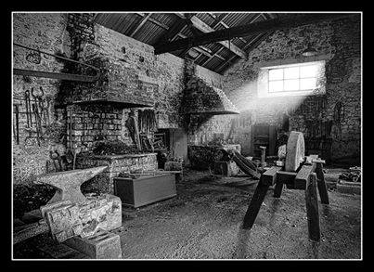

*Grocer/draper 2 8 4*

*Butcher - 3 5*

*Miller 4 3 2\**

*Carpenter/wheelwright 7 7 2*

*Blacksmith/farrier 5 6 2*

*Shoe/boot maker 8 5 2*

*Tailor 2 8 4*

*Dressmaker - 7 1*

*Builder/bricklayer - 5 3*

*Inside the Old Blacksmith Shop *1x wind & steam; 1x steam*

By 1851 there was a druggist/chemist in the village. It’s interesting to see what could be purchased at the time in that the owner confirmed to the coroner at an inquest the sale of 1 oz of laudanum & 1oz of sweet nitre to Samuel Storey, who then used these purchases to commit suicide in the church vestry in August 1886.

The numbers of heads of household who described their occupation as “farmer” in the 1841, 1851 and 1911 censuses were 48, 56 and 72 respectively. During the same period the number of agricultural workers increased from 124 to 175 in 1851 but then declined to 97 by 1911. It seems that the number of those attempting to farm quite small acreages grew during this period (some of whom had previously been employed on farms), but the number of farmers who relied on members of the family only to help run the business increased, which would account for the fall in the number of employed farm workers.

Another significant type of employment throughout this period was domestic service. Little detail was provided in the 1841 census other than the occupation of “farm servant”, as opposed to “agricultural labourer”. There were 31 farm servants, nearly all of whom were female. In 1851 there were 51 people employed as housekeeper, house servant or farm servant. By 1911 this number had fallen to just 23 in domestic service.

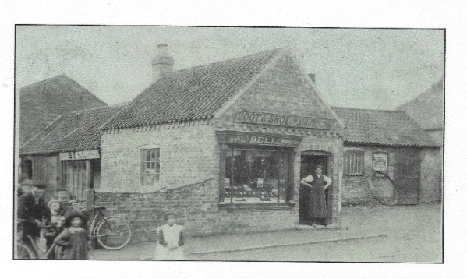New occupations began to appear in 1851 and were more in evidence by 1911: railway worker; traction engine driver; cycle agent; motor engineer; district nurse; warehouseman.

A new category of citizen appeared after 1909, the Old Age Pensioner, who was awarded between 2s to 5s a week following the OAP Act of 1908, if you were deemed of “good character”. In 1911 the census recorded 14 OAPs in North Kelsey, but also 4 people “on

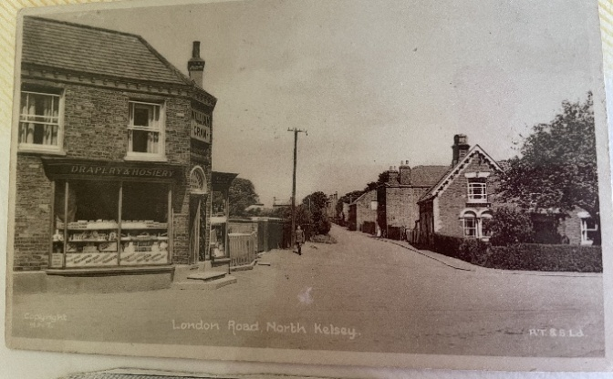 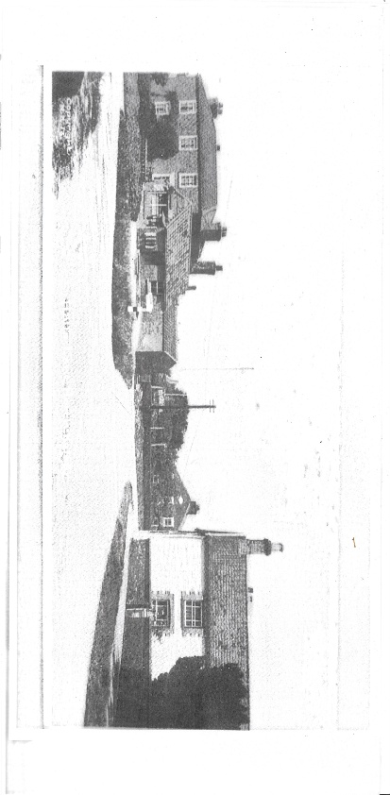

**What’s On – Community Events**

**The Women’s Institute**

Meet at 7.15pm in the Village Hall on the 2nd Wednesday of every month. Visitors & new members are always welcome. For more details call Joyce on 01652 678549

**The Kelsey Knits & Natters**

Every Tuesday afternoon 4 – 6pm at The Butchers Arms Pub.

Everyone is welcome even if they don’t knit. They can bring other crafts along.

**North Kelsey Youth Club**

The North Kelsey Youth Club is held every Friday night in the North Kelsey Village Hall from 7.00pm to 8.30pm for ages 9 years and above. Entry 50p.

**The Methodist Church**

Second Monday of the Month Tea & Cake from 2.30 – 4.00pm in the Methodist Chapel

They also hold the North Kelsey History Meeting at the same time. Come along, have a chat and reminisce.

**The Village Hall** Contact details from Joyce 07716942012

Village Fair: 13th to 15th June

"Rosianna Ceilidh Band" in Village Hall Sat 14th 7pm

Garage Sale July 19th

Claxby Community Choir Sept 27th

Mondays: 9-15 to 10-15 am, FitSteps. 10-20 to 11-20 am, Pilates

Tuesdays: 6 to 7 pm, Pilates Wednesdays: 2-3pm Tai Chi

1st Saturday of every month: Bingo

2nd Thursday of every month: Lunch Club @ 12 noon

3rd Thursday of every month: Breakfast Club 9-30 to 11-30 am.

Wednesdays in school term time, Kelsey Stay & Play Toddler group £2 per family to include refreshments.

Fridays: Early Years Alliance “Get Active”

**North Kelsey Bowls Club**

Meet every Saturday at 4pm – During Summer Months

**1st Grasby Scouts**

Tuesday Evenings from 7.30 – 9.00pm Are you aged 10 – 13 and looking for adventure?

Do you want to learn how to light fires, cook on them and other #skillsforlife?

If your answer to any of these questions is yes, then email [1stgrasbygsl@gmail.com](mailto:1stgrasbygsl@gmail.com) for more information.

**All Hallows Church**

Services at All Hallows - The first Sunday of the month 10.30am. Morning prayer, reflection and hymns.

Coffee Mornings - 2nd Saturday of the month, 10am to noon.

October to March at the village hall. April to September in the church.

Contact Revd Marian if you want more details. [marian.toyne63@gmail.com](mailto:marian.toyne63@gmail.com) or 01652 679057

***Contact Us***

Email is our preferred method of communication where you’ll expect a prompt response. Please note the Clerk is employed for 8 hours per week, so there may be a delay in returning calls. [clerk@northkelseyparishcouncil.gov.uk](mailto:clerk@northkelseyparishcouncil.gov.uk)

**Councillors**

Cllr David Waite – Chairman

Cllr Susan March – Vice Chair

Cllr Pamela Bryan, Cllr John Cundill,

Cllr Graham Harris, Cllr Reg Hunt,

Cllr John Slater, Cllr Jan Waite,

Cllr Mary Williams

**Your Ward Councillors**

Lincolnshire County Council Cllr J. Bean

[cllrj.bean@lincolnshire.gov.uk](mailto:cllrj.bean@lincolnshire.gov.uk)

West Lindsey District Council Cllr P. Morris [Cllrp.morris@west-lindsey.gov.uk](mailto:Cllrp.morris@west-lindsey.gov.uk) 07946 322048

Parish Council Meetings are held on the second Tuesday of every month at 7.15pm in the Village Hall.

You can email us or come along to the meeting; we have a Public Session every month.

**Newsletter Editor**

The place to share what matters to your community. What’s On, Sport, Groups, History. Anyone wishing to contact the Editor with their own news, please email Pamela on [cllr.p.bryan@northkelseyparishcouncil.gov.uk](mailto:cllr.p.bryan@northkelseyparishcouncil.gov.uk)